I. Abstract 2012
1. Enrollment and Underwriting
(1) The number of NHI beneficiaries has increased by 82 thousand from the end of the previous year. Category 1 beneficiaries saw the largest increase. Category 5 beneficiaries saw the largest increase in scope.
At the end of 2012, there were 23 million beneficiaries, an increase of 82 thousand, or 0.4% from the previous year. Category1 saw the biggest increased at 179 thousand people, while Category 5 saw an increase of 12.0% and had the largest increase from the previous year.
(2) The sex ratio of all beneficiaries was 98.6.
By the end of 2012, 11,558 thousand beneficiaries were male and 11,723 thousand beneficiaries were female; the sex ratio was 98.6. The sex ratio of the registered population at the end of 2012 was 100.3. NHI beneficiaries were excluded from the population of corrective institutions; the NHI program targets all nationals and foreign workers in Taiwan as beneficiaries, which is why the sex ratio of NHI beneficiaries is less than that of registered population.
(3) The number of young dependents had gone down, causing the number of beneficiaries in the ＜15 age group to decrease by 89 thousand from the previous year.
There were 3,339 thousand (14.3%) beneficiaries in the ＜15 age group at the end of 2012; beneficiaries in the age group of 15-64 numbered 17,379 thousand (74.6%); beneficiaries above 65 numbered 2,563 thousand (11.0%). Compared with the previous year, beneficiaries in the ＜15 age group decreased by 89 thousand, owing mainly to a decrease in dependents.
(4) The average insured payroll-related amount for Categories 1 to 3 totaled NT$34,087, while the highest amount was for professional and technical personnel at NT$67,376.
At the end of 2012, the average insured payroll-related amount totaled NT$34,087, an increase of only 1.7% from the previous year. The highest amount was for professional and technical personnel at NT$67,376. Associations for farmers, fishermen and irrigation were the lowest at NT$21,900.
(5) The average insured payroll-related amount for males was NT$37,270, which is higher than the NT$30,888 for females.
At the end of 2012, the average insured payroll-related amount for males was NT$37,270, which is higher than the NT$30,888 for females. Males showed higher average insured amounts than females in all age groups, of which, there were significant differences occurring in age 35-64, the difference in amount surpassed NT8,000.
(6) The premium receivable increased by NT$14 billion from the previous year, while the highest increase was in Category 1 at NT$13 billion.
Premium receivables accounted for NT$482 billion in 2012, an increase of NT$14 billion or 2.9% from the previous year. Compared with the previous year, Category 1 showed the greatest increase at NT$13 billion, while Category 6 had the highest decrease at NT$1 billion.
(7) The premium burden ratio of beneficiaries was 37.3%, while group insurance applicants and government subsidies were at 37.8% and 24.9% respectively.
The premiums receivable from the beneficiaries and the group insurance applicants (including government subsidies to specific targets) in 2012 were NT$ 180 billion (37.3%) and NT$ 182 billion (37.8%) respectively. NT$ 120 billion (24.9%) was from government subsidies.
2. Financial Status
(1) Premiums receivable were NT$483 billion, with a collection rate of 97.3%.
Premiums receivable totaled NT$483 billion in 2012, an increase of 2.9% from the previous year. Premium collected totaled NT$470 billion, an increase of 3.2% from the previous year. The total collection rate was 97.3%.
(2) Government subsidy receivables totaled NT$145 billion, for a collection rate of 96.1%.
Government subsidy receivables (including statutory subsidies and subsidies to specific targets) totaled NT$145 billion, NT$139 billion was collected, for a collection rate of 96.1%.
(3) Delinquent charge receivables totaled NT$120 million, with a collection rate of 70.7%.
Delinquent charge receivables totaled NT$120 million in 2012, NT$85 million was collected, for a collection rate of 70.7%.
(4) In accrual basis, the surplus was NT$27 billion.
Observing the general situation of financial revenue and expenditure (accrual basis), the insurance revenues totaled NT$511 billion in 2012, an increase of 2.8% from the previous year. Insurance costs were NT$484 billion, an increase of 4.7% from the previous year. Surplus totaled NT$27 billion. In the end of 2011, the accumulated balance was minus NT$6 billion, which should be covered using the reserve fund. Therefore the reserve fund accumulated balance in 2012 was NT$21 billion.
3. Contracting and Management of Medical Care Institutions
(1) The number of contracted medical care institutions increased by 570 from the previous year; however, the number of hospitals decreased by 3.
The total number of contracted medical care institutions in 2012 was 26,317, an increase of 570 (2.2%) from the previous year. If compared with the previous year, the number of hospitals decreased by 3, while the number of clinics and other medical care institutions increased by 298 and 275.
(2) Rate of contracts signed with the contracted medical care institutions was 93.7%; the lowest was for Taipei City, at 83.2%.
As of end of 2012, 93.7% of medical care institutions have entered into contracts with the BNHI. Broken down by locale, the lowest was for Taipei City at 83.2%, while the highest was for Lienchiang County at 100%.
(3) Chiayi City had the largest number of contracted medical care institutions per 10,000 beneficiaries at 17.9, while Taipei City had the smallest at 7.5.
At the end of 2012, the number of contracted medical care institutions per 10,000 beneficiaries (contracted medical care institutions / beneficiaries ×10,000) was 11.3. When broken down by locale, Chiayi City had the largest number at 17.9, while Taipei City had the smallest number at 7.5.
(4) The total number of beds in contracted medical care institutions decreased by 24 from the end of the previous year; however, insured beds showed an increase of 1,171.
At the end of 2012, the total number of beds in contracted medical care institutions was 146,353, a decrease of 24 from the previous year, of which 121,249 were insured beds and 25,104 were non-insured beds. If compared with the previous year, the number of insured beds increased by 1,171, while non-insured beds decreased by 1,195.
(5) The percentage of insured beds was 82.8%, while academic medical centers saw the largest increase at 3.5 percentage points.
At the end of 2012, the percentage of insured beds was 82.8%, an increase of 0.8 percentage points from the previous year, of which academic medical centers accounted for 73.0%, with the greatest increase of 3.5 percentage points.
(6) Hualien County had the largest number of beds in contracted medical care institutions per 10,000 beneficiaries at 147.1, while the smallest number was in Hsinchu City at 41.0.
As of the end of 2012, the beds of contracted medical care institutions per 10,000 beneficiaries (beds in contracted medical care institutions/beneficiaries ×10,000) was 62.9, of which insured beds accounted for 52.1, and non-insured beds 10.8. When broken down by locale, Hualien County had the largest number of beds at 147.1, while the smallest number was in Hsinchu City at 41.0.
(7) 372 medical care institutions were found to have committed violations, of which the largest group of violators, 150, consisted of medical care institutions which were penalized by reduced reimbursement.
In 2012, 372 medical care institutions were found to have committed violations (1.4%), of which the largest group of violators consisted of medical care institutions which were penalized by reduced reimbursement (150 institutions), 109 were penalized by suspension of contract ranging from 1 month to 3 months, 92 were penalized by corrections, and 21 were penalized by contract termination, which accounted for the smallest group.
4. Medical Benefits
(1) Physician clinics showed the highest medical points for outpatient service, while academic medical centers showed the highest medical points for inpatient service.
The total medical points in 2012 amounted to 566 billion points, making an increase of 2.4% from the previous year. Among which, the total requested points were 529 billion points; co-payment 36 billion points. The total outpatient medical points amounted to 389 billion points, of which physician clinics accounted for the largest proportion, at 40.3%; the total inpatient medical points amounted to 177 billion points, of which academic medical centers accounted for the largest proportion, at 42.3%.
(2) In terms of the average medical points per case, males had a higher amount than females for all age groups.
In 2012, the average medical points per outpatient case were 1,147 points for males, surpassing that for females by 997 points; the average medical points per inpatient case were 60,402 points for males, surpassing that for females by 50,871 points. In terms of the average medical points per case, males had a higher amount than females for all age groups.
(3) Physician clinics accounted for the largest proportion of the approved medical benefit for outpatient services, while academic medical centers accounted for the largest in inpatient services.
In 2012, the total approved medical benefit amounted to 532 billion points, a 3.0% increase from the previous year. Among which, there were 365 billion points for outpatient and 167 billion points for inpatient. Physician clinics had 145 billion points of approved outpatient benefit, being the highest of all, as for the average points per approved case, academic medical centers had the highest amount of 2,163 points; academic medical centers had 71 billion points of approved inpatient benefit, being the highest of all, as for the average points per approved case, academic medical centers had the highest amount of 66,675 points.
(4) Cancer accounted for the highest proportion of medical points. In terms of average medical points per capita, hemophilia ranked the highest.
As at the end of 2012, the number of valid Major Illness/Injury Certificates issued was 961 thousand. Total medical points of major illness/injury in 2012 amounted to 156 billion points. The top three diseases were, respectively, cancer, uremia, and dependence on respirator. In terms of the average medical points per capita for major illness/injury, hemophilia ranked the highest for both outpatient and inpatient services.
(5) Uremia accounted for the largest proportion of medical points for major illness/ injury for both genders for outpatient services, while cancer was largest for inpatient services.
In 2012, uremia accounted for the largest proportion of outpatient medical points for major illness/injury and cancer the second largest, for both genders; cancer accounted for the largest proportion of inpatient medical points for major illness/injury and dependence on respirator second, for both genders.
(6) In terms of the average co-payments per case, academic medical centers had the highest amount both in outpatient and inpatient services.
The average co-payments per case were NT$98 for outpatient services and NT$4,456 for inpatient services in 2012. Analyzed by contracted category, academic medical centers had the highest amount both in outpatient and inpatient services (NT$330 for outpatient and NT$5,723 for inpatient).
(7) Males had higher average co-payments per case than females for all age groups.
In 2012, the average co-payments per outpatient case were NT$100 for males and NT$97 for females; the average co-payments per inpatient case were NT$4,582 for males and NT$4,322 for females. Males showed higher amounts than females in all age groups. The most significant difference was seen in age group 45-64, at NT$605 per inpatient case.
(8) The approved rate for out-of-plan services was 26.9%.
The total advanced medical expense claims for out-of-plan services approved were NT$1,906 million in 2012, an increase of 14.9% from the previous year. The total approved amount was NT$512 million, an increase of 0.1% from the previous year. The approval rate was 26.9%, among which, NT$388 million was for outpatient service with an approved rate of 44.6%; there was NT$1,518 million for inpatient services, with an approved rate of 22.3%.
II. Main Indicators 2012
 |  | Unit |  | 2012 |  | Annual Growth Rate  (%)

Enrollment and Underwriting
Group Insurance Applicants | No. |  | 750,851 |  |  |  | 2.8
Beneficiaries  Category 1  Category 2  Category 3  Category 4  Category 5  Category 6  Male  Female  Under 15  age 15-64  65 and over | 1000 Persons |  | 23,281  12,649  3,868  2,691  152  348  3,573  11,558  11,723  3,339  17,379  2,563 |  |  |  | 0.4  1.4  -2.4  -2.2  -5.4  12.0  -0.8  0.2  0.5  -2.6  0.6  2.7
Average Insured Payroll-related Amount for  Categories 1 – 3 | NT$ |  | 34,087 |  |  |  | 1.7
Premium Receivable  Contribution from the Insured  Contribution from Group Insurance Applicants  Contribution from Government Subsidies | 100 Million NT$ |  | 4,824  1,800  1,822  1,202 |  |  |  | 2.9  2.0  4.6  1.7

Financial Status
Premium Collected  Contribution from the Insured & Group Insurance Applicants  Contribution from Government Subsidies | 100 Million NT$ |  | 4,701  3,551  1,150 |  |  |  | 3.2  2.5  5.6
Insurance Revenues（Accrual Basis） | 100 Million NT$ |  | 5,107 |  |  |  | 2.8
Insurance Cost（Accrual Basis） | 100 Million NT$ |  | 4,842 |  |  |  | 4.7
Contracting and Management of Medical Care Institutions
Contracted Medical Care Institutions  Western Medicine  Chinese Medicine  Dentistry  Pharmacies | No. |  | 26,317  10,504  3,205  6,349  5,284 |  |  |  | 2.2  1.4  2.1  1.4  4.9

 | Unit | 2012 |  | Annual Growth Rate  (%)
Beds in Contracted Medical Care Institutions  Acute Beds  Chronic Beds | Beds | 146,353  128,551  17,802 |  | 0.0  -0.1  0.9
Insured Beds in Contracted Medical Care Institutions  Acute Beds  Chronic Beds | Beds | 121,249  104,101  17,148 |  | 1.0  1.0  0.7

Medical Benefits
Medical Points (Commission cases excluded)  Outpatient Services  Requested Points  Co-payment  Inpatient Services  Requested Points  Co-payment | 100 Million Points | 5,655  3,890  3,600  290  1,765  1,693  73 |  | 2.4  3.1  3.3  0.7  0.9  0.9  0.5
Medical Service Cases (Commission cases excluded)  Outpatient Services  Inpatient Services | 1,000 Cases | 365,406  3,177 |  | 1.0  0.3
Average Medical Points per Case (Commission cases excluded)  Outpatient Services  Inpatient Services | Points | 1,065  55,567 |  | 2.2  0.6
Approved Medical Benefit Payments  Outpatient Services  Inpatient Services | 100 Million Points | 5,317  3,645  1,672 |  | 3.0  3.8  1.3
Approved Medical Payments  Outpatient Services  Inpatient Services | 100 Million NT$ | 4,911  3,373  1,538 |  | 4.2  4.7  2.9
Number of Valid Major Illness/Injury Certificates  Medical Benefit Claims of Major Illness/Injury | Pieces  100 Million Points | 961,265  1,558 |  | 4.6  3.6
III. Statistical Analysis
- Enrollment and Underwriting
The NHI program is a mandatory, single-payer social health insurance system, founded on the principle that all people should have equal access to health care services. Under the NHI scheme, beneficiaries are divided into six categories and each differs in their insured payroll-related amount, premium contribution rate, and premium calculation method. Application(s) are to be made at the agency, school, enterprise, institution, employer, group, or designated departments to which the insured belongs.
（1）Beneficiaries
i. The number of NHI beneficiaries has increased by 82 thousand from the end of the previous year. Category 1 beneficiaries saw the largest increase. Category 5 beneficiaries saw the largest increase in scope.
At the end of 2012, there were 23 million beneficiaries, an increase of 82 thousand, or 0.4% from the previous year. There has been an average annual increase of 0.6% since 2002.  When broken down by beneficiary category, Category 1 had the highest number of beneficiaries at 12,649 thousand, followed by Category 2 at 3,868 thousand, Category 6 at 3,573 thousand, Category 3 at 2,691 thousand, Category 5 at 348 thousand and Category 4 at 152 thousand.  In terms of changes from the previous year, Category1 saw the biggest increased at 179 thousand people, followed by Category 5 with 37 thousand people, Category 6 with 28 thousand people, while Category 2, 3 and 4 showed a decreasing trend, falling by 94 thousand, 59 thousand and 9 thousand people, respectively.  The number of beneficiaries in Category 5 saw an increase of 12.0% and had the largest increase from the previous year, whereas Category 4 showed a decrease of 5.4% and had the largest decrease from the previous year. | Figure 1 Numbers of Beneficiaries by Beneficiary Category  End of 2012  Figure 2 Changes in Beneficiaries by Beneficiary Category  End of 2012 vs. End of 2011
ii. The sex ratio of all beneficiaries was 98.6. The sex ratio in the ＜25 age groups was higher than 100, whereas the ratio for 25-and-over was lower than 100.
By the end of 2012, 11,558 thousand beneficiaries were male and 11,723 thousand beneficiaries were female; the sex ratio was 98.6. Broken down by age, there were more male beneficiaries than females in the <25 age group, and the sex ratio was over 100, whereas females outnumbered males for age 25-and-over, the sex ratios of all age groups were lower than 100.
The sex ratio of the registered population at the end of 2012 was 100.3. NHI beneficiaries were excluded from the population of corrective institutions; the NHI program also targets all nationals and foreign workers in Taiwan as beneficiaries, which is why the sex ratio of NHI beneficiaries is less than that of registered population, while the 25-39 group shows a significant difference compared to all age groups.
Figure 3 Comparison of the Sex Ratio between Beneficiaries and the Registered Population
End of 2012
Note：Figures of registered population are from Department of Household Registration Affairs, MOI.
iii. The number of young dependents had gone down, causing the number of beneficiaries in the ＜15 age group to decrease by 89 thousand from the previous year.
There were 3,339 thousand (14.3%) beneficiaries in the ＜15 age group at the end of 2012; beneficiaries in the age group of 15-64 numbered 17,379 thousand (74.6%); beneficiaries above 65 numbered 2,563 thousand (11.0%). Beneficiaries in the 15-64 age group increased by 104 thousand compared with the previous year, while senior beneficiaries above 65 also showed an increase, of 67 thousand. However, beneficiaries in the ＜15 age group decreased by 89 thousand, owing mainly to a decrease in dependents.
Figure 4 Changes in Beneficiaries by Age
End of 2012 vs. End of 2011
iv. Taipei City had the highest increase of beneficiaries at 37 thousand, whereas Kinmen County showed a larger increased rate of 3.0%.
When broken down by city/county, Taipei City had the highest number of beneficiaries at 4,646 thousand, followed by New Taipei City, Taichung City and Kaohsiung City, all with over 2.5 million, while Lienchiang County had the smallest number at 7 thousand.
If compared with the previous year, Taipei City showed the largest increase at 37 thousand beneficiaries, followed by New Taipei City at 25 thousand and Taichung City at 23 thousand. Pingtung County had the largest decrease at 8 thousand. Among all Locales, Kinmen County had the largest percentage increase, at 3.0%, while Keelung City had the largest decrease, at 1.4%.
Figure 5 Beneficiaries by NHI Regional Division and Locale  End of 2012  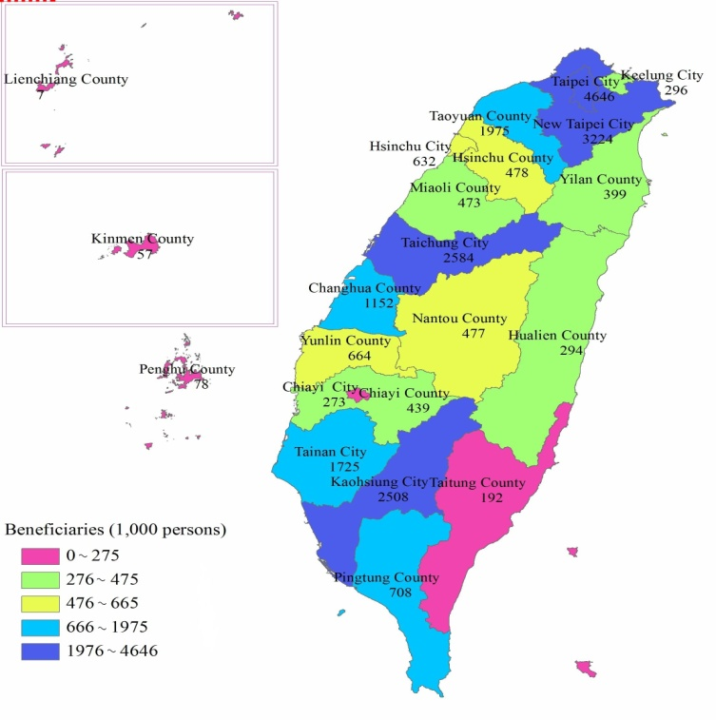 | Figure 6 Changes in Beneficiaries by NHI Regional Division and Locale  End of 2012 vs. End of 2011  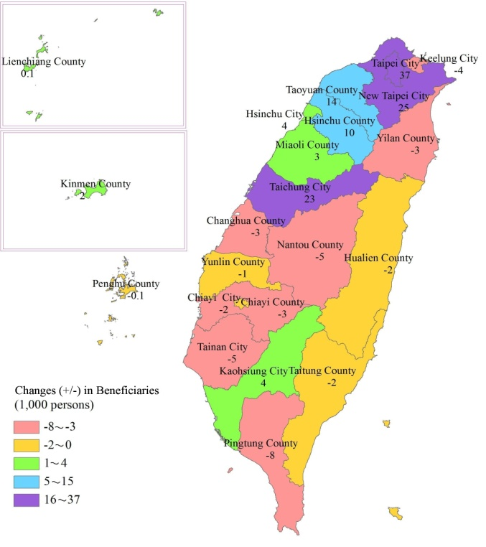
（2）The Insured Payroll-Related Amount
i. The average insured payroll-related amount for Categories 1 to 3 totaled NT$34,087, while the highest amount was for professional and technical personnel at NT$67,376.
At the end of 2012, the average insured payroll-related amount totaled NT$34,087, an increase of only 1.7% from the previous year. The average annual increase was 2.1% over the past ten years. The payroll-related premium base does not apply to the insured in categories 4, 5 and 6, whose average premium was the same as the previous year. The average premium was NT$1,376 for categories 4 and 5, and was NT$1,249 for Category 6.
The average insured payroll-related amounts for Categories 1 to 3 were NT$39,090, NT$26,776, and NT$21,900, respectively. The highest amount was for professional and technical personnel at NT$67,376 with a decrease of 4.7% from the previous year. This was the largest decrease in all beneficiary categories. The average insured payroll-related amount for teaching personnel from public and private institutions and government employees was NT$58,619, which is a 1.5% increase from the previous year. Other categories did not achieve NT$50,000. Associations for farmers, fishermen and irrigation were the lowest at NT$21,900, which remained the same as the previous year.

Figure 7 The Average Insured Payroll- Related Amount for Categories 1-3 by Category | Figure 8 The Average Insured Payroll- Related Amount for Category 1 by Item
ii. The average insured payroll-related amount for males was NT$37,270, which is higher than the NT$30,888 for females.
At the end of 2012, the average insured payroll-related amount for males was NT$37,270, which is higher than the NT$30,888 for females. When broken down by age, the age group of 40-44 male had the highest average insured amount. For females, the age group of 45-49 had the highest average insured amount. The age group of 15-19 was the lowest for both males and females. Males showed higher average insured amounts than females in all age groups, of which, there were significant differences occurring in age 35-64, the difference in amount surpassed NT8,000.
Figure 9 The Average Insured Payroll-Related Amount for Categories 1-3 by Gender and Age
End of 2012
（3） Premiums Receivable
Premium revenues are the main source of funds for NHI. The rates of premium contributions vary by the type of insured. Category 4 compulsory military servicemen and the social servicemen, Category 5 low-income households, and Category 6 unemployed veterans receive full subsidies from the government.
i. The premium receivable increased by NT$14 billion from the previous year, while the highest increase was in Category 1 at NT$13 billion.
Premium receivables accounted for NT$482 billion in 2012, an increase of NT$14 billion (2.9%) from the previous year. The average annual increase in the most recent 10 years was 4.8%. The premiums receivable for Category 1 was the largest at NT$311 billion, followed by Category 2 at NT$67 billion, Category 6 at NT$58 billion, Category 3 at NT$39 billion, Category 4 and Category 5 at NT$2 and NT$6 billion.
Compared with the previous year, Category 1 showed the greatest increase at NT$12,622 million, followed by Category 2 at NT$998 million. The number of beneficiaries at the end of the year showed a decrease compared to the same time of the year previous, however, since the decrease happened after the second half of the year, premiums receivable increased. There was an NT$781 million increase of premiums receivable in Category 5. Category 6 had the highest decrease at NT$537 million. The number of beneficiaries at the end of the year showed an increase compared to the same time of the year previous, however, since the number showed a decreasing trend at the beginning of the year, premiums receivable still decreased. The premiums receivable of Categories 3 and 4 showed a decrease at NT$204 and NT$46 million respectively.
Figure 10 Premiums Receivable by Category  2012 | Figure 11 Changes in Premiums Receivable by Category  2012 vs. 2011
ii. The premium burden ratio of beneficiaries was 37.3%, while group insurance applicants and government subsidies were at 37.8% and 24.9% respectively.
The premiums receivable from the beneficiaries and the group insurance applicants (including government subsidies to specific targets) in 2012 were NT$ 180 billion (37.3%) and NT$ 182 billion (37.8%), respectively. NT$ 120 billion (24.9%) was from government subsidies, of which, NT$ 102 billion (21.1%) was from the central government, NT$ 17 billion (3.6%) was from the provincial/municipal governments and NT$ 1 billion (0.3%) from the country/city governments.
Figure 12 Premiums Receivable by Source
End of 2012

2. Financial Status¹
The main source of revenue for the National Health Insurance scheme is garnered from premium revenue, which is made collectively by the insured, the group insurance applicants, and the government. In recent years, factors such as the aging of the overall population, introduction of new medical technologies, and increased care for major disease patients have led to substantial increases in medical expenditures. Premium revenue has long been inadequate to meet medical expenditures, and the NHIA is facing a serious financial pressure. To ease the financial deficit, the NHIA plans to tap new resources and cut expenses. Furthermore, premium rate were adjusted on April, 2010, to prevent the deficits gap from widening. In order to expand the premium basis and ensure fairness and reasonability in premium contributions, the NHI has also been actively promoting reform of the financial system (i.e., 2nd Generation NHI).
(1) Premium Collections
i. Premiums receivable were NT$483 billion, with a collection rate of 97.3%.
Premiums receivable² totaled NT$483 billion in 2012, an increase of 2.9% from the previous year. Premium collected totaled NT$470 billion, an increase of 3.2% from the previous year. The total collection rate was 97.3%. Premiums receivable from the insured and group insurance applicants totaled NT$363 billion (NT$25 billion was from government subsidies to specific targets), of which NT$355 billion was collected (NT$24 billion was from government subsidies to specific targets); and the total collection rate was 97.9%. Premiums receivable from the government (statutory government subsidies) totaled NT$120 billion, and NT$115 billion was collected, for a collection rate 95.6%.
Figure 13 Premiums
2012
ii. Government subsidy receivables totaled NT$145 billion, for a collection rate of 96.1%.
Government subsidy receivables (including statutory subsidies³ and subsidies to specific targets⁴) totaled NT$145 billion; NT$139 billion was collected, for a collection rate of 96.1%. Statutory government subsidy receivables was NT$120 billion; NT$115 billion was collected, for a collection rate of 95.6% (central government subsidy receivables were NT$102 billion, with a collection rate of 100%; there was NT$17 billion in subsidies for provincial and municipal governments, and NT$12 billion was collected, for a collection rate 69.0%; there was NT$1 billion in subsidies for county and city governments, with a collection rate of 100%), subsidies to specific targets for contribution of the insured, and group insurance applicants subsidized by governments totaled NT$25 billion, while NT$24 billion was collected, for a collection rate of 98.5%.
Figure 14 Government Subsidy Receivables
2012
iii. Delinquent charge receivables totaled NT$120 million, with a collection rate of 70.7%.
Insured and group insurance applicants should pay delinquent charges in the case where they pay late premiums. Delinquent charge receivables totaled NT$120 million in 2012, NT$85 million was collected, for a collection rate of 70.7%. The delinquent charges of Category 1 totaled NT$104 million, which was the largest and accounted for 86.8%. Category 6 totaled NT$13 million, which was the second largest and accounted for 11.1%. Category 2 totaled NT$2 million, which accounted for 2.0%. Category 3 totaled NT$52 thousand, which accounted for 0.04%.
Figure 15 Delinquent Charge Receivables by Beneficiary Category
2012
(2) Financial Revenue and Expenditure
i. In accrual basis, the surplus was NT$27 billion.
Observing the general situation of financial revenue and expenditure (accrual basis), the insurance revenue totaled NT$511 billion in 2012, an increase of 2.8% from the previous year, of which premium revenues were NT$483 billion (or accounted for 94.5%), which was the largest proportion of insurance revenue. Insurance costs were NT$484 billion, an increase of 4.7% from the previous year, of which medical expenses were NT$480 billion (or accounted for 99.2%), which was the largest proportion of insurance costs. Surplus totaled NT$27 billion. In the end of 2011, the accumulated balance was minus NT$6 billion, which should be covered using the reserve fund. Therefore the reserve fund accumulated balance in 2012 was NT$21 billion.
Figure 16 Financial Status ─ Accrual Basis
ii. In cash basis (cash flow), revenue was NT$528 billion; expenditure was NT$480 billion; repayment of loans totaled NT$49 billion.
Observing the general situation of cash flow, revenue was NT$528 billion in 2012, an increase of 8.7% from the previous year, of which premium revenues were NT$503 billion (or accounted for 95.2%), which was the largest proportion of revenue. Expenditures were NT$480 billion, an increase of 3.5% from the previous year, of which medical expenses were NT$480 billion (or accounted for 99.9%), which was the largest proportion of expenditures. Repayment of loans totaled NT$49 billion. As of the end of 2012, the accruement of loans totaled NT$58 billion.
Figure 17 Financial Cash Flow Status
Notes:
- Data in this chapter was last updated on May 9, 2013.
- The "premium receivable" in this chapter refers to the premium amount that has been corrected based on the queries/requests by the insured or the group insurance applicants.
- In this chapter, statutory subsidies provided by the different levels of governments shall be determined in accordance with the subsidy levels prescribed in the National Health Insurance Act.
- "Government subsidies to specific targets" (non-statutory subsidies from the government) in this chapter refers to the separately-budgeted government subsidies for premium payments, which were originally payable by the insured or the group insurance applicants pursuant to the National Health Insurance Act.
3. Contracting and Management of Medical Care Institutions
Contracted medical care institutions are categorized as contracted hospitals and clinics, pharmacies, medical laboratory institutions and other medical care institutions appointed by the competent authorities, which so far include midwifery clinics, home nursing care facilities, psychiatric rehabilitation centers, physical therapy clinics, occupational therapy clinics, medical examination facilities, and radiology centers.
(1) Contracted Medical Care Institutions
i. The number of contracted medical care institutions increased by 570 from the previous year; however, the number of hospitals decreased by 3.
The total number of contracted medical care institutions in 2012 was 26,317, an increase of 570 (2.2%) from the previous year, with an average annual increase of 2.3% over the past ten years. The number of hospitals was 491, the number of clinics was 19,567, the number of other medical care institutions was 6,259. If compared with the previous year, the number of hospitals decreased by 3, while the number of clinics and other medical care institutions increased by 298 and 275.
ii. The number of pharmacies and Western medicine clinics increased by 247 and 145, respectively.
Among contracted hospitals at the end of 2012, the numbers of Western medicine hospitals and Chinese medicine hospitals were 478 and 13 (a respective decrease of 1 and 2 from the previous year). Among contracted clinics, the number of Western medicine clinics had the largest number at 10,026, followed by dental clinics at 6,349, and Chinese medicine clinics at 3,192. If compared with the previous year, Western medicine clinics had the biggest increase at 145, followed by dental clinics at 86, and Chinese medicine clinics at 67. Among other medical care institutions pharmacies were the most numerous at 5,284 and experienced the largest rise, an increase of 247 from the previous year. Other medical care institutions, which included medical laboratory institutions, home nursing cares, midwifery clinics, community psychiatric rehabilitation, physical & occupational therapy clinics and medical radiology centers had 975 facilities, an increase of 28 from the previous year.
Figure 18 Contracted Medical Care Institutions
Note："Others" includes medical laboratory institutions, home nursing cares, midwifery clinics, community psychiatric rehabilitation, physical & occupational therapy clinics and medical radiology centers.
iii. Rate of contracts signed with the Contracted Medical Care Institutions was 93.7%; the lowest was for Taipei City, at 83.2%.
As of end of 2012, 93.7% of medical care institutions have entered into contracts with the BNHI. Broken down by locale, the lowest was for Taipei City at 83.2%, followed by Chiayi City at 92.8%, Taichung City at 93.6%; other city/county was over 93.7% for the total rate of contract signed, the highest of which was Lienchiang County at 100%.
Figure 19 Percentages of Medical Care Institutions that have Entered into Contracts with the BNHI by Locale
End of 2012
iv. The number of contracted medical care institutions in New Taipei City saw the highest increase, 119 from the previous year; Penghu County and Hsinchu City both experienced decreases.
When broken down by locale, the number of contracted medical care institutions in New Taipei City had the largest number at 4,040, followed by Taichung City, Taipei City and Kaohsiung City, which all had over 3,000; Lienchiang County, at 8, had the fewest. If compared with the previous year, Lienchiang County remained the same, while Penghu County and Hsinchu City decreased by 1 and 4, other city/county showed an increase, and New Taipei City showed the highest increase at 119.
Figure 20 The Number of Contracted Medical Care Institutions by Locale  End of 2012  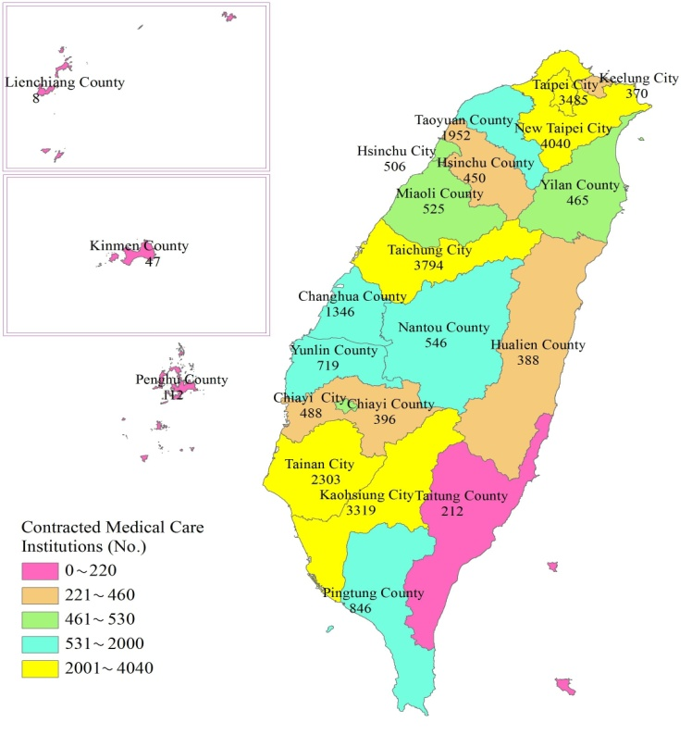 | Figure 21 Changes in Contracted Medical Care Institutions by Locale  End of 2012 vs. End of 2011  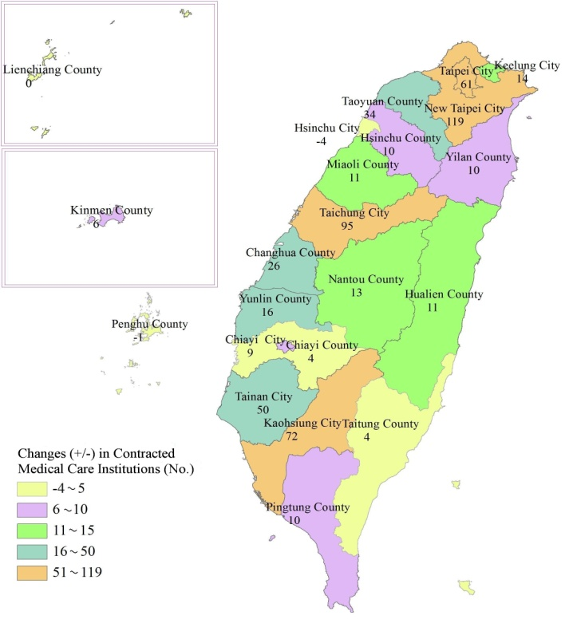
v. Chiayi City had the largest number of contracted medical care institutions per 10,000 beneficiaries at 17.9, Taipei City had the smallest at 7.5.
At the end of 2012, the number of contracted medical care institutions per 10,000 beneficiaries (contracted medical care institutions / beneficiaries ×10,000) was 11.3. When broken down by locale, Chiayi City had the largest number at 17.9, followed by Taichung City at 14.7, and Penghu County at 14.4. Taipei City had the smallest number at 7.5, followed by Hsinchu City at 8.0 and Kinmen County at 8.3, while Chiayi County, Hsinchu County and Taoyuan County were all under 10.
Figure 22 The Number of Contracted Medical Care Institutions per 10,000 Beneficiaries by Locale
End of 2012
(2) Insured Beds
When setting up of wards in contracted hospitals, the following must be taken into consideration: 1. The standard requirements for setting up wards by medical care institutions, and 2. The ratio of the number of beds in insurance wards. Hospital wards are divided into acute and chronic wards. An insurance ward refers to a ward provided by a contracted hospital to an insurance beneficiary in receiving hospital care without charging the patient additional fees.
i. The total number of beds in contracted medical care institutions decreased by 24 from the end of the previous year; however, insured beds showed an increase of 1,171.
At the end of 2012, the total number of beds in contracted medical care institutions was 146,353, a decrease of 24 from the previous year. The average annual increase was 1.7% for the past 10 years, of which 121,249 were insured beds and 25,104 were non-insured beds. If compared with the previous year, the number of insured beds increased by 1,171, while non-insured beds decreased by 1,195.
Figure 23 Number of Beds in Contracted Medical Care Institutions  End of 2012 | Figure 24 Changes in Number of Beds in Contracted Medical Care Institutions  End of 2012 vs. End of 2011
ii. The percentage of insured beds was 82.8%, while academic medical centers saw the largest increase at 3.5 percentage points.
At the end of 2012, the percentage of insured beds was 82.8%, an increase of 0.8 percentage points from the previous year. Broken down by contracted category, the percentage of insured beds in academic medical centers was 73.0%, 78.9% for metropolitan hospitals, 89.1% for local community hospitals and 100.0% for physician clinics. | Figure 25 Share of Insured Beds by Contracted Category
If compared with the previous year, metropolitan hospitals saw a decrease of 0.1 percentage points, while the others indicated an increase, with academic medical centers exhibiting the greatest increase of 3.5 percentage points.
iii. The total number of acute insured beds increased by 1,044 from the end of the previous year; however, acute non-insured beds showed a decrease of 1,220.
Broken down by type of bed, there were 128,551 acute beds at the end of 2012; 104,101 of which were insured beds and 24,450 were non-insured. Chronic beds numbered 17,802, of which 17,148 were insured beds and 654 were non-insured beds.  If compared with the previous year, the number of acute beds decreased by 176. This was mainly due to a decrease by 1,220 in the number of non-insured beds. The number of acute insured beds increased by 1,044 beds from the previous year; the number of Chronic beds increased by 152, while the number of insured and non-insured beds increased by 127 and 25 beds, respectively.  At the end of 2012, insured acute beds accounted for 74.9% of the total (an increase of 1.2 percentage points from the previous year); chronic insured beds accounted for 96.3% (a decrease at 0.1 percentage points). | Figure 26 The Number of Beds in Contracted Medical Care Institutions by Type of Bed  End of 2012  Figure 27 Changes in Number of Beds in Contracted Medical Care Institutions by Type of Bed  End of 2012 vs. End of 2011
iv. Taipei City had the most beds in contracted medical care institutions at 21,089; at the same time it saw the largest decrease, 214, from the previous year.
In terms of locale, Taipei City had the most beds in contracted medical care institutions at 21,089, followed by Kaohsiung City at 19,336 beds and Taichung City at 19,105 beds; New Taipei City, Taoyuan County and Tainan City all had over 10,000 beds; Lienchiang County had the fewest beds at 52, followed by Kinmen County and Penghu County at 255 and 474 beds respectively, which were all fewer than 500 beds.
If compared with the previous year, numbers in Lienchiang County, Kinmen County, and Penghu County remained the same, while other city/county saw fluctuations: New Taipei City saw the largest increase in number of beds at 163, followed by Chiayi City at 145 and Keelung City at 101; Taipei City had the largest decrease at 214, followed by Taoyuan County at 139 beds, and Miaoli County at 112 beds.
Figure 28 The Number of Beds in Contracted Medical Care Institutions by Locale  End of 2012  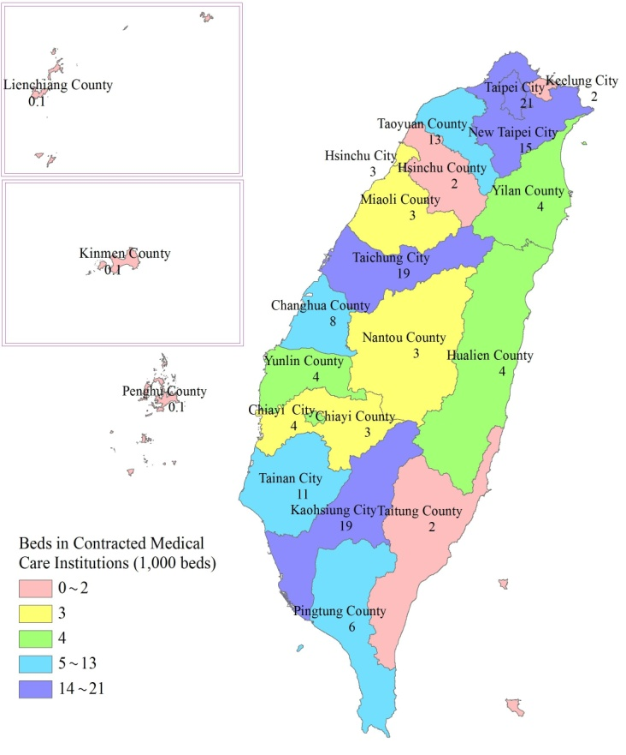 | Figure 29 Changes in Number of Beds in Contracted Medical Care Institutions by Locale  End of 2012 vs. End of 2011  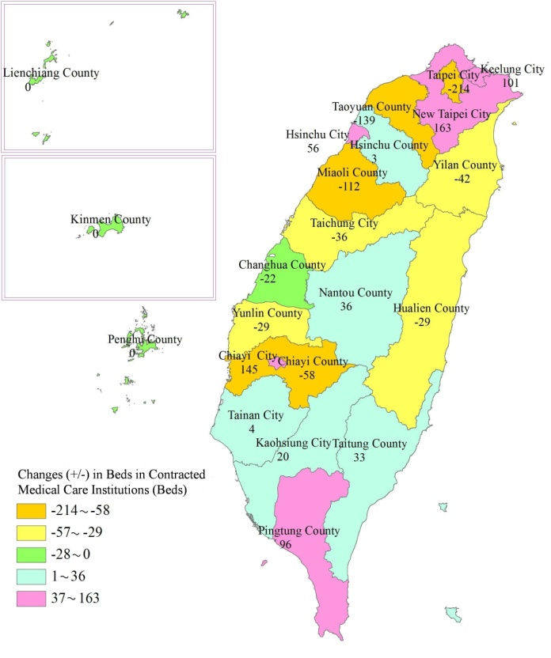

v. Hualien County had the largest number of beds in contracted medical care institutions per 10,000 beneficiaries at 147.1, while the smallest number was in Hsinchu City at 41.0.
As of the end of 2012, the beds of contracted medical care institutions per 10,000 beneficiaries (beds in contracted medical care institutions/beneficiaries ×10,000) was 62.9, of which insured beds accounted for 52.1, and non-insured beds 10.8.
When broken down by locale, Hualien County had the largest number of beds per 10,000 beneficiaries at 147.1, followed by Chiayi City at 143.1. Hsinchu City accounted for the smallest number of beds at 41.0, followed by Kinmen County at 44.9. Hualien County and Chiayi City both had the largest number of insured beds in contracted medical care institutions per 10,000 beneficiaries at 129.5 and 120.4 beds, respectively. Hsinchu City accounted for the smallest number of beds at 33.6, followed by Taipei City at 34.7.
Figure 30 The Beds of Contracted Medical Care Institutions per 10,000 Beneficiaries by Locale
End of 2012
(3) Management of Contracted Medical Care Institutions
Since its establishment, the NHIA has been putting more emphasis on the supervision of contracted medical care institutions to maintain the quality of medical services provided. In addition, the Administration also follows the “Regulations Governing Contracting and Management of National Health Insurance Medical Care Institutions” to reinforce violation reviews as well as management of abnormal activity. The reviews focus on severe violations such as committing fraud to falsely claim insurance benefits. When appropriate, the NHIA assists the related judicial authorities in the investigation of serious offenses committed by contracted medical care institutions.
i. 372 medical care institutions were found to have committed violations, of which the largest group of violators, 150, consisted of medical care institutions which were penalized by reduced reimbursement.
In 2012, 372 medical care institutions were found to have committed violations (1.4%), a decrease of 48 institutions (11.4%) from the previous year. Of these the largest group of violators consisted of medical care institutions which were penalized by reduced reimbursement (150 institutions), 109 were penalized by suspension of contract ranging from 1 month to 3 months, 92 were penalized by corrections, and 21 were penalized by contract termination, which accounted for the smallest group.
Figure 31 Penalties and Disciplinary Actions against Contracted Medical Care Institutions
2012

4. Medical Benefits
The National Health Insurance System has comprehensively implemented a global budget payment system on medical expenses since July, 2002. The medical benefits under the global budget payment system are paid primarily on the basis of service volume. To elevate the quality of healthcare services and promote better health, the NHIA gradually introduced the “Case Payment” and “Pay for Performance” systems as well. Furthermore, to improve the effectiveness of healthcare services and provide complete holistic care, the NHIA effected the Tw-DRGs (Taiwanese Diagnosis Related Groups) payment system in January, 2010, and the pilot project of the “Capitation” payment system in July, 2011.
According to the “Regulations Governing Examination of Medical Care Services for National Health Insurance Medical Care Institutions”, applications, complete with relevant documents, cases serviced by a medical services institution under the NHI should be submitted in paper or electronic format by the 20th of the month following the service. Applications in electronic format may be divided in two stages, one from the 1st to the 15th of the month and the other from the 16th to the end of the month; relevant documents (summary reports) should be submitted by the 5th and the 20th of the following month. For filing of inpatient cases, if the insured has not checked out of the hospital at the end of the month, the expenses should be filed altogether after the insured has checked out. For chronically hospitalized patients, filing may be done every two months. Monthly filing is also allowed if deemed necessary.
Medical service institutions under the NHI should finish filing within the specified period, leaving no incomplete applications or errors therein. The insurer should process the provisional payments within the specified time limit after having received the documents and should deliver the reviewed results within 60 days. If the results cannot be delivered in time, a provisional payment of the full amount should be made. Any disagreement with the review results of the medical services raised by the medical services institutions under the NHI may be disputed within 60 days from the arrival of the notice from the insurer. The insurer should review the disputed cases within 60 days of receiving such complaints. For the sectors operating under the global budget payment system, if a medical services institution under the NHI disagrees with the disputed results and is qualified for a second review, it may apply for a one-time second review within 15 days of receiving the disputed results. The insurer should deliver the reviewed results within 45 days of accepting the application for a second review.
(1) Medical Benefit Claims (Commission cases excluded)
The total medical points in 2012 amounted to 566 billion points, making an increase of 2.4% from the previous year. Among which, the total requested points were 529 billion points; co-payment 36 billion points. The total outpatient medical points amounted to 389 billion points, an increase of 3.1% from the previous year. Among which, the requested points were 360 billion points; co-payment, 29 billion points. The total inpatient medical points amounted to 177 billion points, an increase of 0.9% from the previous year. Among which, the requested points were 169 billion points; co-payment, 7 billion points.
A total of 365 million outpatient cases were filed in 2012, showing an increase of 1.0% from the previous year. A total of 3 million inpatient cases were filed, showing an increase of 0.3% from the previous year.
The average medical points per case were 1,065 points for outpatient, 55,567 for inpatient. The average length of stay was 9.9 days.
i. Physician clinics showed the highest medical points for outpatient service, while academic medical centers showed the highest medical points for inpatient service.
Broken down by contracted category, the highest medical points for outpatient services in 2012 was seen in physician clinics at 157 billion points (40.3%), followed by metropolitan hospitals at 84 billion points, academic medical centers at 83 billion points, and local community hospitals at 40 billion points (together accounting for 53.1%); the highest medical points for inpatient service was seen from academic medical centers at 75 billion points (42.3%), metropolitan hospitals at 70 billion points (39.8%), local community hospitals at 29 billion points (16.7%), and physician clinics at 2 billion points (1.2%).
The average medical points per outpatient case were, in descending order, 2,400 points for academic medical centers, 1,848 points for metropolitan hospitals, 1,367 points for local community hospitals, 612 points for physician clinics, 466 points for other medical institutions and 322 points for pharmacies. The average medical points per inpatient case were, in descending order, 71,393 points for academic medical centers, 48,913 points for metropolitan hospitals, 47,329 points for local community hospitals, and 29,128 points for physician clinics.
Figure 33 Outpatient Medical Points  by Contracted Category  2012 | Figure 34 Inpatient Medical Points  by Contracted Category  2012
ii. Broken down by the global budget payment system, hospitals represented the largest proportion at 64.6%.
Broken down by the global budget payment system, hospitals had the highest medical points in 2012 at 366 billion points (191 billion points for outpatient and 174 billion points for inpatient services) or 64.6%, followed by physician clinics at 101 billion points (99 billion points for outpatient and 2 billion points for inpatient services) or 17.8%, the Chinese medicine institutions at 21 billion points, dentistry at 37 billion points and dialysis at 38 billion points.
The average medical points per case were 1,845 points for outpatient and 56,171 points for inpatient service in hospitals, 521 points for outpatient and 29,127 points for inpatient service in physician clinics, 541 points in Chinese medicine, 1,190 points in dentistry and 46,551 points in Dialysis.
iii. In terms of the average medical points per case, males had a higher amount than females for all age groups.
Analyzed by gender, outpatient medical points amounted to 188 billion points (48.4%) for males and 201 billion points (51.6%) for females in 2012. The average medical points per case were 1,147 points for males, surpassing that for females by 997 points. Broken farther down by age group, females had higher outpatient medical points than males in all groups above 15 years of age. In terms of average medical points per case, males had a higher amount than females for all age groups.
Figure 36 Outpatient Medical Points  by Gender and Age  2012 | Figure 37 Average Medical Points per Outpatient Case by Gender and Age  2012
Analyzed by gender, inpatient medical points were 95 billion points (53.6%) for males and 82 billion points (46.4%) for females in 2012. The average medical points per case were 60,402 points for males, surpassing that for females by 50,871 points. Broken farther down by age group, females had higher inpatient medical points than males in groups 15-44 years of age, and males had higher numbers than females in other groups. In terms of average medical points per case, males had a higher amount than females for all age groups.
Figure 38 Inpatient Medical Points  by Gender and Age  2012 | Figure 39 Average Medical Points per Inpatient Case  by Gender and Age  2012
iv. The total medical points claimed by the five municipalities and the special municipality, Taoyuan County, accounted for more than 70%.
In terms of locale, the total outpatient medical points for Taipei City amounted for 69 billion points (17.6%) in 2012, being the highest of all, followed by Taichung City at 51 billion points (13.1%), Kaohsiung City at 49 billion points (12.6%) and New Taipei City at 47 billion points (12.2%). The total medical points claimed by the five municipalities and the special municipality, Taoyuan County, accounted for more than 70% of all medical points claimed. Analyzed by gender, females claimed a higher amount of outpatient medical points than males. Chiayi, Kinmen and Lienchiang counties were the only three locales where males claimed higher medical points than females. In terms of the average medical points per case, males had a higher amount than females for all locales.
Figure 40 Outpatient Medical Points by Gender and Locale
2012
In terms of locale, the total inpatient medical points for Taipei City amounted for 39 billion points (22.0%) in 2012, being the highest of all, followed by Kaohsiung City at 24 billion points (13.7%), Taichung City at 24 billion points (13.4%) and Taoyuan County at 17 billion points (9.4%). The total medical points claimed by the five municipalities and the special municipality, Taoyuan County, accounted for more than 70% of all the medical points claimed. Analyzed by gender, males claimed a higher amount of outpatient medical points than females. Hsinchu City was the only locale where females claimed higher medical points than males. In terms of the average medical points per case, males had a higher amount than females. Lienchiang county was the only locale where females had a higher amount than males.
Figure 41 Inpatient Medical Points by Gender and Locale
2012
v. Consultation, treatment and medical supplies accounted for the largest proportion of the medical expenses for outpatient services, while ward fees accounted for the largest in inpatient services.
In terms of the actual detailed expenses, the total outpatient expenses in 2012 amounted to 389 billion points, 188 billion points for males and 201 billion points for females. Consultation, treatment and medical supplies accounted for the largest proportion of the expenses for both genders, with drug fees second largest.
Broken down by age group, diagnosis fees accounted for the largest proportion of the expenses in 0-14 age group. Consultation, treatment and medical supplies accounted for the largest proportion for all age groups except 0-14. Diagnosis fees accounted for the second largest in age groups 15-29 and 30-44, while drug fees were largest in age groups 45-64 and 65+.
Figure 42 Detailed Outpatient Medical Expenses by Gender  2012 | Figure 43 Detailed Outpatient Medical Expenses by Age  2012
The total inpatient expenses in 2012 amounted to 173 billion points. Ward fees accounted for the largest proportion of the expenses, while drug fees were second largest and surgical fees were third. Inpatient expenses totaled 94 billion points for males. Ward fees accounted for the largest proportion of the expenses; drug fees, second; and therapeutic procedure fees, third. Inpatient expenses totaled 79 billion points for females. Ward fees accounted for the largest proportion of the expenses; surgical fees, second; and drug fees, third.
Broken down by age group, ward fees accounted for the largest proportion of the expenses in all age groups. Therapeutic procedure fees accounted for the second largest, and drug fees the third, in age groups 0-14 and 65+. Surgical fees accounted for the second largest, and drug fees the third, in age groups 15-29 and 30-44. Drug fees accounted for the second largest, and surgical fees the third, in age group 45-64.
Figure 44 Top 5 Detailed Inpatient Medical Expenses by Gender  2012 | Figure 45 Top 3 Detailed Inpatient Medical Expenses by Age  2012
(2) Approved Medical Benefit (Co-payment excluded, Commission Cases Included)
i. The total approved medical benefit amounted to 532 billion points, a 3.0% increase from the previous year.
In 2012, the total approved medical benefit amounted to 532 billion points, a 3.0% increase from the previous year. Among which, there were 365 billion points for outpatient, a 3.8% increase from the previous year and 167 billion points for inpatient, a 1.3% increase from the previous year.
The total approved medical expenses amounted to NT$491 billion, a 4.2% increase from the previous year. Among which, there were NT$337 billion for outpatient, a 4.7% increase from the previous year and NT$154 billion for inpatient, a 2.9% increase from the previous year.
ii. Physician clinics accounted for the largest proportion of the approved medical benefit for outpatient services, while academic medical centers accounted for the largest in inpatient services.
Broken down by contracted category, physician clinics had 145 billion points of approved outpatient benefit in 2012, being the highest of all, followed by academic medical centers and metropolitan hospitals at 78 billion points. As for the average points per approved case, academic medical centers had the highest amount of 2,163 points, followed by metropolitan hospitals at 1,605 points and local community hospitals at 1,205 points.
Academic medical centers had 71 billion points of approved inpatient benefit in 2012, being the highest of all, followed by metropolitan hospitals at 66 billion points and local community hospitals at 28 billion points. As for the average points per approved case, academic medical centers had the highest amount of 66,675 points, followed by metropolitan hospitals at 44,354 points and local community hospitals at 42,304 points.
Figure 47 Approved Outpatient Medical Benefit by Contracted Category  2012 | Figure 48 Approved Inpatient Medical Benefit by Contracted Category  2012
(3) Medical Utilization for Major Illness/Injuries
i. The number of valid Major Illness/Injury Certificates issued in 2012 was 961 thousand. Cancer accounted for the largest proportion of all.
As at the end of 2012, the number of valid Major Illness/Injury Certificates issued was 961 thousand, showing an increase of 43 thousand (4.6%) from the end of the previous year. 464 thousand (48.2%) cancer certificates were issued, being the highest of all, followed by chronic psychiatric disorder at 208 thousand (21.7%), generalized autoimmune syndrome requiring lifelong treatments at 85 thousand (8.9%) and uremia at 71 thousand (7.4%).
Figure 49 Numbers of Valid Major Illness/ Injury Certificates Issued
2012
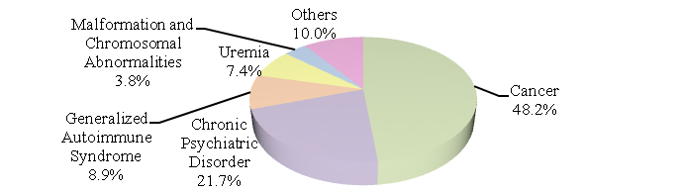
ii. Cancer accounted for the highest proportion of medical points. In terms of average medical points per capita, hemophilia ranked the highest.
Total medical points of major illness/injury in 2012 amounted to 156 billion points. The top three diseases were, respectively, cancer, uremia, and dependence on respirator. Outpatient services amounted to 85 billion points; the top three diseases were uremia, cancer and chronic psychiatric disorder. Inpatient services amounted to 71 billion points; cancer, dependence on respirator and chronic psychiatric disorder ranked top three in diseases.
 | Table 1 Top 10 Major Illness/Injury in 2012
Outpatient |  |  |  | Inpatient
Rank | Category of Major Illness/Injury | Medical Points (million points) | % | Category of Major Illness/Injury | Medical Points (million points) | %
- | Total | 85,071 | 100.0 | Total | 70,772 | 100.0
1 | Uremia | 39,170 | 46.0 | Cancer | 31,016 | 43.8
2 | Cancer | 27,749 | 32.6 | Dependence on respirator | 16,064 | 22.7
3 | Chronic psychiatric disorder | 4,710 | 5.5 | Chronic psychiatric disorder | 8,344 | 11.8
4 | Generalized autoimmune syndrome | 3,285 | 3.9 | Uremia | 5,160 | 7.3
5 | Hemophilia | 2,927 | 3.4 | Acute cerebrovascular disease | 3,068 | 4.3
6 | Rare diseases | 1,885 | 2.2 | Major trauma | 1,494 | 2.1
7 | Organ transplants | 1,764 | 2.1 | Cirrhosis of liver | 1,254 | 1.8
8 | Dependence on respirator | 817 | 1.0 | Generalized autoimmune syndrome | 951 | 1.3
9 | Congenital metabolic disease | 402 | 0.5 | Malformation and chromosomal abnormalities | 875 | 1.2
10 | Malformation and chromosomal abnormalities | 399 | 0.5 | Organ transplants | 713 | 1.0
In terms of the average medical points per capita for major illness/ injury in 2012, hemophilia ranked the highest at 2,912 thousand points for outpatient services, followed by uremia at 522 thousand points, rare diseases at 354 thousand points, organ transplants at 206 thousand points and hemolytic disease at 177, thousand points; hemophilia ranked the highest at 1,296 thousand points for inpatient services, followed by dependence on respirators at 733 thousand points, severe malnutrition at 683 thousand points, burns at 641 thousand points and complications of premature infants at 450 thousand points.
Table 2 Top 10 Average Medical Points per Capita on Major Illness/Injury in 2012
Outpatient |  |  |  | Inpatient
Rank | Category of Major Illness/Injury | Average Medical Points per Capita  (points) | Multiples | Category of Major Illness/Injury | Average Medical Points per Capita  (points) | Multiples
- | Average | 103,718 | 1.0 | Average | 234,494 | 1.0
1 | Hemophilia | 2,911,971 | 28.1 | Hemophilia | 1,295,873 | 5.5
2 | Uremia | 522,288 | 5.0 | Dependence on respirator | 732,984 | 3.1
3 | Rare diseases | 354,283 | 3.4 | Severe malnutrition | 683,439 | 2.9
4 | Organ transplants | 206,391 | 2.0 | Burns | 640,727 | 2.7
5 | Hemolytic disease | 177,007 | 1.7 | Complications of premature infants | 450,354 | 1.9
6 | Multiple sclerosis | 170,861 | 1.6 | Rare diseases | 427,868 | 1.8
7 | Severe malnutrition | 150,596 | 1.5 | Congenital immunodeficiency | 385,945 | 1.6
8 | Dependence on respirator | 150,187 | 1.4 | Motor neuron disease | 374,096 | 1.6
9 | Congenital immunodeficiency | 133,088 | 1.3 | Hemolytic disease | 320,232 | 1.4
10 | Leprosy | 76,100 | 0.7 | Creutzfeldt Jakob disease | 283,371 | 1.2
iii. Uremia accounted for the largest proportion of medical points for major illness/ injury for both genders for outpatient services, while cancer was largest for inpatient services.
In 2012, the total outpatient medical points for major illness/injury filed by males amounted to 43 billion points (50.7%), and those from females amounted to 42 billion points (49.3%). Uremia accounted for the largest proportion of all and cancer the second largest, for both genders. For males, hemophilia ranked the third largest, chronic psychiatric disorder fourth, and organ transplants fifth. For females, generalized autoimmune syndrome ranked the third largest, chronic psychiatric disorder fourth and rare diseases fifth.
Table 3 Top 10 Outpatient Major Illness/Injury in 2012 by Gender
Rank | Category of Major Illness/Injury  (Male) | Medical Points (million points) | % | Category of Major Illness/Injury  (Female) | Medical Points (million points) | %
- | Total | 43,141 | 100.0 | Total | 41,931 | 100.0
1 | Uremia | 19,101 | 44.3 | Uremia | 20,068 | 47.9
2 | Cancer | 13,967 | 32.4 | Cancer | 13,781 | 32.9
3 | Hemophilia | 2,884 | 6.7 | Generalized autoimmune syndrome | 2,678 | 6.4
4 | Chronic psychiatric disorder | 2,350 | 5.4 | Chronic psychiatric disorder | 2,359 | 5.6
5 | Organ transplants | 1,150 | 2.7 | Rare disease | 754 | 1.8
6 | Rare disease | 1,131 | 2.6 | Organ transplants | 614 | 1.5
7 | Generalized autoimmune syndrome | 607 | 1.4 | Dependence on respirator | 415 | 1.0
8 | Dependence on respirator | 402 | 0.9 | Malformation and chromosomal abnormalities | 217 | 0.5
9 | Cirrhosis of liver | 258 | 0.6 | Congenital metabolic disease | 192 | 0.5
10 | Congenital metabolic disease | 210 | 0.5 | Acute cerebrovascular disease | 152 | 0.4
In 2012, the total inpatient medical points on major illness/injury filed by males amounted to 41 billion points (57.2%), and those from females amounted to 30 billion points (42.8%). For both genders, cancer accounted for the largest proportion of all, dependence on respirator second, chronic psychiatric disorder third, uremia fourth and acute cerebrovascular disease fifth.
 |  | Table 4 Top 10 Inpatient Major Illness/Injury in 2012 by Gender
Rank | Category of Major Illness/Injury  (Male) |  | Medical Points (million points) | % | Category of Major Illness/Injury  (Female) | Medical Points (million points) | %
- | Total |  | 40,502 | 100.0 | Total | 30,270 | 100.0
1 | Cancer |  | 18,235 | 45.0 | Cancer | 12,781 | 42.2
2 | Dependence on respirator |  | 8,931 | 22.1 | Dependence on respirator | 7,133 | 23.6
3 | Chronic psychiatric disorder |  | 4,611 | 11.4 | Chronic psychiatric disorder | 3,733 | 12.3
4 | Uremia |  | 2,563 | 6.3 | Uremia | 2,597 | 8.6
5 | Acute cerebrovascular disease |  | 1,767 | 4.4 | Acute cerebrovascular disease | 1,301 | 4.3
6 | Major trauma |  | 1,113 | 2.7 | Generalized autoimmune syndrome | 747 | 2.5
7 | Cirrhosis of liver |  | 932 | 2.3 | Malformation and chromosomal abnormalities | 429 | 1.4
8 | Organ transplants |  | 478 | 1.2 | Major trauma | 382 | 1.3
9 | Malformation and chromosomal abnormalities |  | 446 | 1.1 | Cirrhosis of liver | 322 | 1.1
10 | Rare disease |  | 246 | 0.6 | Organ transplants | 235 | 0.8

iv. Hemophilia accounted for the largest proportion of outpatient claims for age groups under 30, while uremia ranked the first for age groups 30 and above.
The outpatient claims of major illness/injury in 2012 were, respectively, 2 billion points (2.2%) for the age group 0-14, 4 billion points (4.3%) for the age group 15-29, 10 billion points (12.1%) for the age group 30-44, 38 billion points (45.1%) for the age group 45-64 and 31 billion points (36.4%) for the age group 65+.
In terms of disease, hemophilia accounted for the largest proportion of outpatient claims of major illness/injury and rare disease ranked the second for age groups 0-14 and 15-29. For age groups 30-44, 45-64 and 65+, uremia ranked first and cancer second.
Table 5 Top 5 Outpatient Major Illness/Injury in 2012 by Age Group
 | 0-14 | 15-29 | 30-44 | 45-64 | 65+
Medical Points | 1,848 Million Points | 3,653 Million Points | 10,272 Million Points | 38,345 Million Points | 30,954 Million Points
Rank
1 | Hemophilia | Hemophilia | Uremia | Uremia | Uremia
1 | 27.7% | 26.0% | 30.4% | 46.5% | 57.4%
2 | Rare disease | Rare disease | Cancer | Cancer | Cancer
2 | 26.6% | 16.6% | 27.5% | 36.4% | 33.7%
3 | Malformation and chromosomal abnormalities | Cancer | Chronic psychiatric disorder | Chronic psychiatric disorder | Generalized autoimmune syndrome
3 | 12.1% | 11.8% | 15.7% | 5.1% | 2.8%
4 | Poliomyelitis | Chronic psychiatric disorder | Hemophilia | Generalized autoimmune syndrome | Chronic psychiatric disorder
4 | 9.5% | 11.7% | 9.1% | 4.3% | 2.0%
5 | Chronic psychiatric disorder | Uremia | Generalized autoimmune syndrome | Organ transplants | Dependence on respirator
5 | 6.2% | 11.6% | 5.2% | 2.9% | 1.3%
v. Cancer accounted for the largest proportion of inpatient claims for all age groups except group 65+, while dependence on respirator ranked the first for age group 65+.
The inpatient claims of major illness/injury in 2012 were, respectively, 2 billion points (2.4%) for the age group 0-14, 3 billion points (4.0%) for the age group 15-29, 8 billion points (11.7%) for the age group 30-44, 27 billion points (38.4%) for the age group 45-64, and 31 billion points (43.6%) for the age group 65+.
In terms of disease, cancer accounted for the largest proportion of inpatient claims of major illness/injury for all age groups except group 65+. Dependence on respirator ranked first for age group 65+. Chronic psychiatric disorder ranked the second for the 15-64 age groups.
Table 6 Top 5 Inpatient Major Illness/Injury in 2012 by Age Group
 | 0-14 | 15-29 | 30-44 | 45-64 | 65+
Medical Points | 1,690 Million Points | 2,820 Million Points | 8,265 Million Points | 27,156 Million Points | 30,841 Million Points
Rank
1 | Cancer | Cancer | Cancer | Cancer | Dependence on respirator
1 | 29.3% | 29.7% | 37.7% | 54.7% | 39.3%
2 | Malformation and chromosomal abnormalities | Chronic psychiatric disorder | Chronic psychiatric disorder | Chronic psychiatric disorder | Cancer
2 | 27.6% | 24.7% | 34.9% | 14.4% | 38.0%
3 | Dependence on respirator | Major trauma | Dependence on respirator | Dependence on respirator | Uremia
3 | 14.9% | 11.1% | 7.3% | 10.3% | 9.9%
4 | Rare disease | Dependence on respirator | Major trauma | Uremia | Acute cerebrovascular disease
4 | 6.7% | 10.6% | 3.2% | 6.7% | 5.5%
5 | Poliomyelitis | Malformation and chromosomal abnormalities | Uremia | Acute cerebrovascular disease | Chronic psychiatric disorder
5 | 5.0% | 4.8% | 3.0% | 3.9% | 2.7%
(4) Co-payments for Medical Expenses
Co-payments for medical expenses totaled NT$36 billion in 2012, a 0.7% increase from the previous year. Among which, outpatient co-payments amounted to NT$29 billion and inpatient co-payments NT$7 billion.
i. In terms of the average co-payments per case, academic medical centers had the highest amount both in outpatient and inpatient services.
The average co-payments per case were NT$98 for outpatient services and NT$4,456 for inpatient services in 2012. Analyzed by contracted category, academic medical centers had the highest amount both in outpatient and inpatient services (NT$330 for outpatient and NT$5,723 for inpatient). Metropolitan hospitals ranked second (NT$238 for outpatient and NT$4,133 for inpatient).
Figure 50 Average Co-payments per Outpatient Case by Contracted Category  2012 | Figure 51 Average Co-payments per Inpatient Case by Contracted Category  2012
ii. Males had higher average co-payments per case than females for all age groups.
In terms of gender, the average co-payments per outpatient case were NT$100 for males and NT$97 for females in 2012; the average co-payments per inpatient case were NT$4,582 for males and NT$4,322 for females. Broken down by age group, the average co-payments per case increased with age. The average co-payments per case for the age group 65+ represented 1.7 times that of the age group 0-14 for outpatient services, and 3.7 times that for inpatient services. Males showed higher amounts than females in all age groups. The most significant difference was seen in age group 45-64, at NT$605 per inpatient case.
Figure 52 Average Co-payments per Outpatient Case by Gender and Age  2012 | Figure 53 Average Co-payments per Inpatient Case by Gender and Age  2012

(5) Reimbursement of Advanced Medical Expenses for Out-of-Plan Services
i. The claims for out-of-plan services approved were NT$1,906 million, with an approved rate of 26.9%.
The total advanced medical expense claims for out-of-plan services approved were NT$1,906 million in 2012, an increase of 14.9% from the previous year. The total approved amount was NT$512 million, an increase of 0.1% from the previous year. The approval rate was 26.9%, among which, NT$388 million was for outpatient service with an approved rate of 44.6%; there was NT$1,518 million for inpatient services, with an approved rate of 22.3%.
Figure 54 Applied Amount for Out-of-Plan Services | Figure 55 Approval Rate for Out-of-Plan Services
ii. China accounted for the highest proportion of all overseas claims with the highest approval rate.
Broken down by area, domestic claims accounted for NT$894 million with an approval rate of 22.4%. Out of country claims amounted to NT$1,012 million with an approval rate of 30.8%. Advanced medical expenses for services rendered in China amounted to NT$436 million and represents 43.1% of all overseas claims, being the highest of all. The approval rate was 52.2%. The claims for services rendered in the United States amounted to NT$281 million and contributed to 27.8% of the total overseas claims, being the second highest. The approval rate was 7.7%.

Figure 56 Reimbursements of Advance Medical Expenses for Out-of-Plan Services
2012
Notes:
- Data updated on April 30, 2013.
- Medical Benefit Claims exclude commission cases.
- Medical expenses imply both requested/approved points and co-payments.
- The detailed medical expenses indicate actual medical expenses incurred for each item, including co-payments.
- Patients’ co-payment does not include registration fees.
- Prior to the implementation of the global budget payment system, 1 point was equal to NT$1. After the global budget payment system was implemented, 1 point for any item under general services should be calculated according to the “Point Value of Global Budget Payment System” in this chapter. For other items, 1 point was equal to NT$1 in principle.

